**FD1108S TES Customer Requirement Test Results**

1.Support config the GE and PON port description function

PON port description and display command:

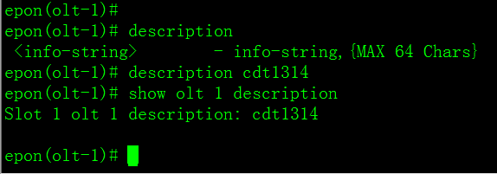

GE port description and display command:

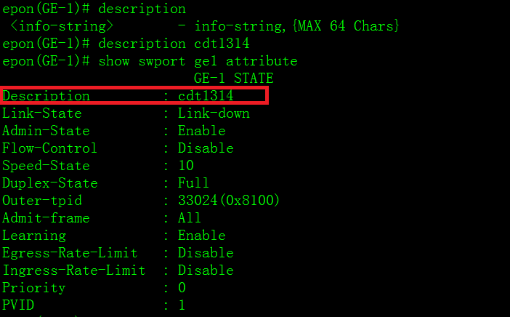

1.Automatically back up system logs to the specified server to prevent hackers from deleting the system log of the device

Configuration command:

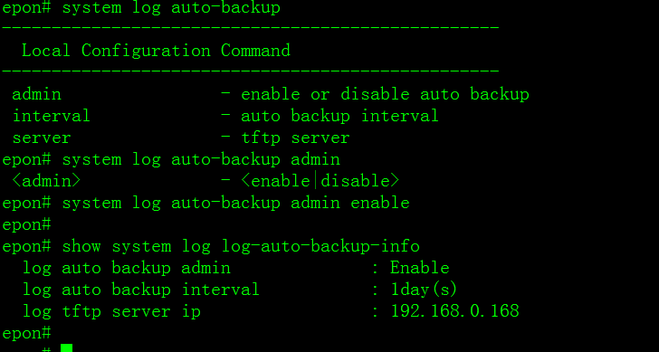

1.Support onu template can be configured link sla speed limit function；

System template config commands are as follows: (for ONU all links)：

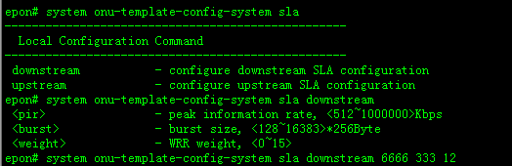 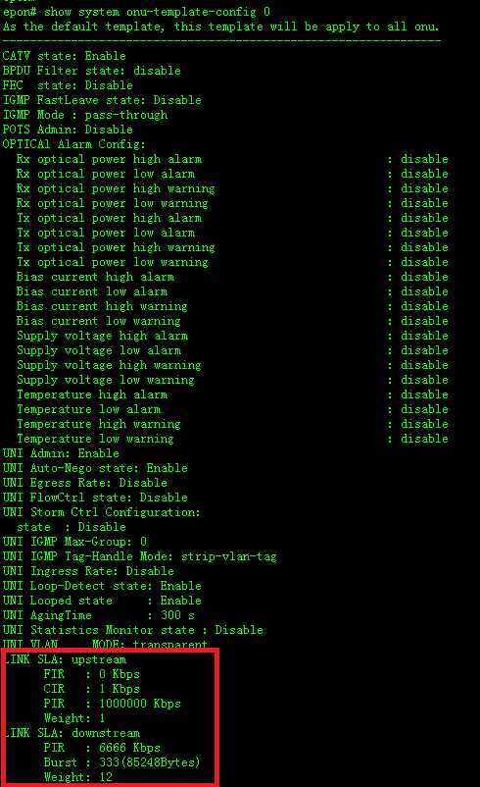

User template related commands are as follows: (Slave configuration can be carried out for the specific link)

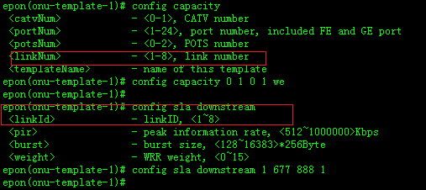

Show command：epon(onu-template-1)# show system onu-template-config 1

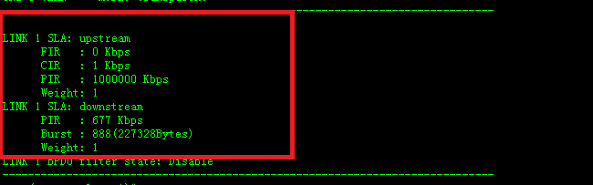

1.Support OLT to configure ONU ports to filter out ndp BPDU packets, and can support bind the function to ONU through the template. (This function is based on the ONU link bpdu filter)

Discrete related commands are as follows:

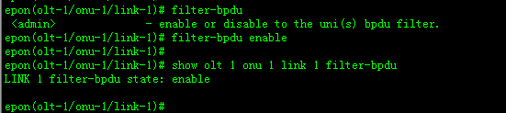

System template related commands are as follows: (For ONU all the link to send the filtering function):

**Configuration:**

epon# system onu-template-config-system filter-bpdu

<admin> - enable or disable to the uni(s) bpdu filter.

epon# system onu-template-config-system filter-bpdu enable

Display command:

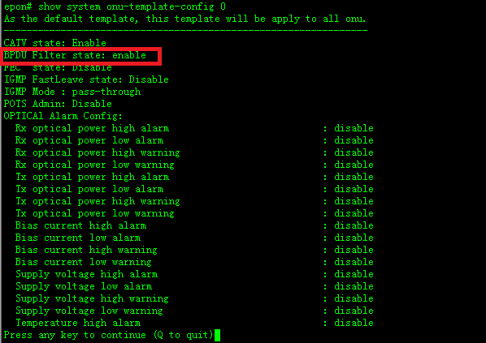

User template config command are as follows: (The link can be issued for the specific filter function):

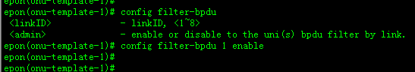

Display command：epon(onu-template-1)# show system onu-template-config 1

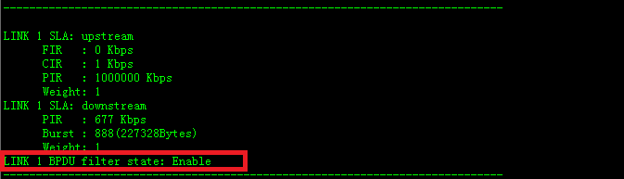

1.There is a threshold for the ONU port to be configured with the storm suppression function in the ONU profile.

Related commands for system template are as follows:

(For onu all of port config)

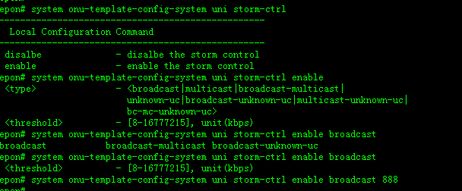

Display command：epon# show system onu-template-config 0

UNI Storm Ctrl Configuration:

state : Enable

type : broadcast

rate : 888(kbps)

User templates related commands are as follows: (for a specific port to deliver this feature);

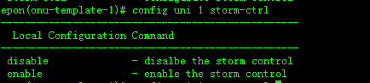

Display command：epon# show system onu-template-config 1

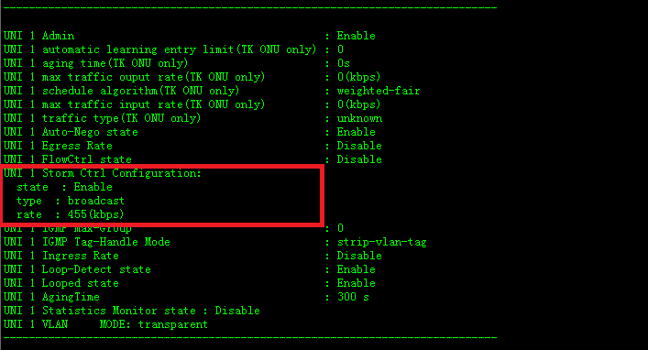

1.Support for setting ONU optical power alarm threshold in ONU profile (oam supports v2.1 and v3.0)

Discrete configuration related commands are as follows

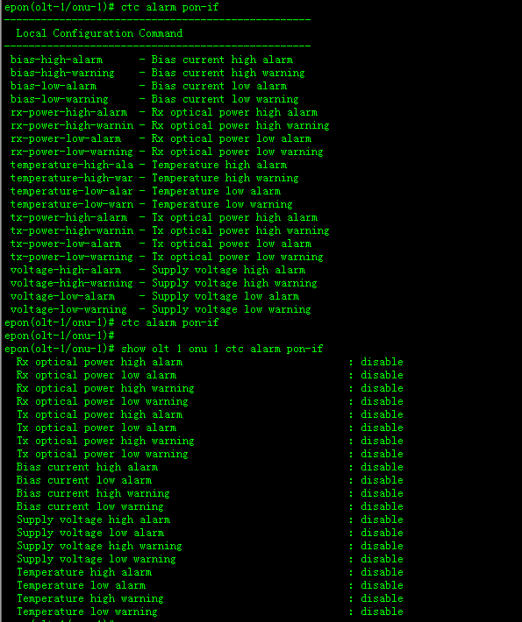

System template related commands are as follows: (Default onu onfa distribution of the configuration)

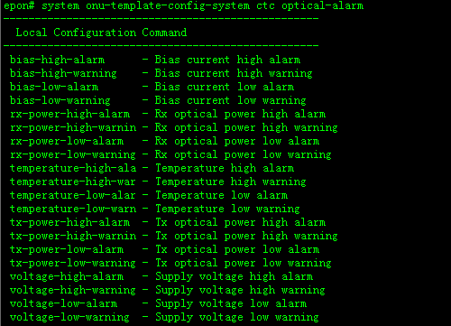

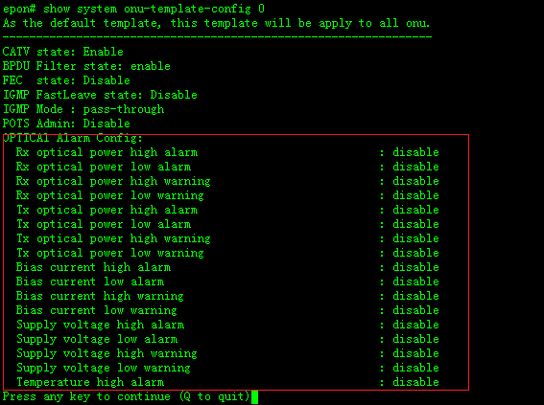

Related commands of user template are as follows: (This alarm function can be delivered for the specific binding onu)

